**Forthcoming presentations**



**Venue: ADD VENUE**

**Time:** **ADD TIME**

**All welcome!**

Tea and Coffee will be served



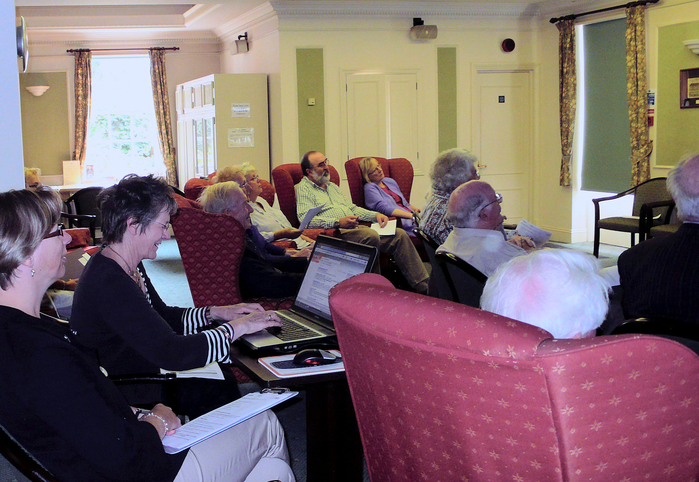



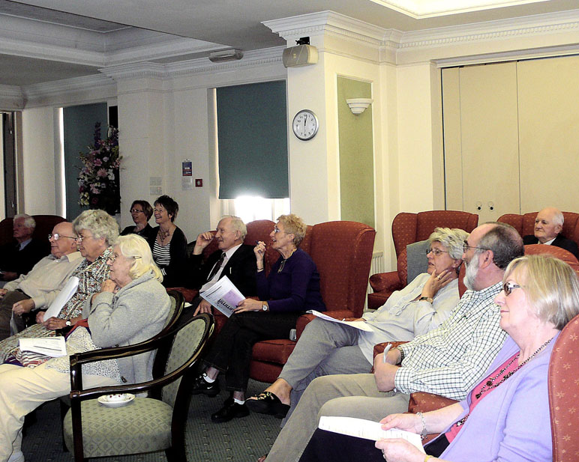

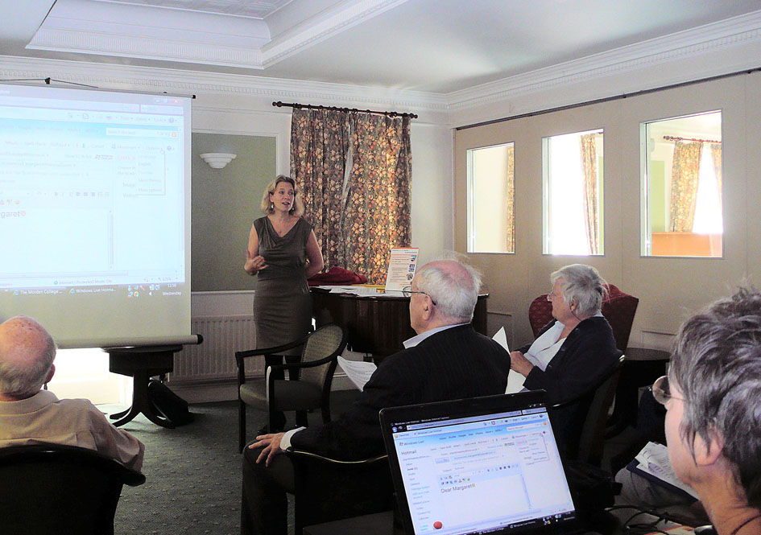

**Seminar Dates:**

**Wed 11 November 2009**

**Wed 16 December 2009**

**Wed 3 February 2010**

5B0310

© Computer Sharing Centre Ltd 2010 | www.computersharingcentre.com